**EIT Health: More than 90 students competed at Innovation Days for Health**

**News 05/12/2019**

[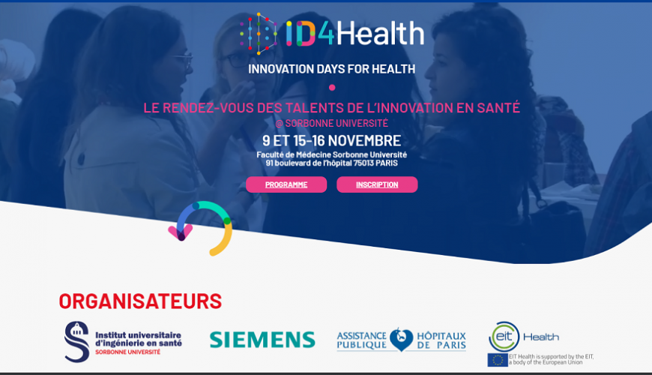](https://eit.europa.eu/sites/default/files/eit_health_15-16_november.png)

[**EIT Health**](https://www.eithealth.eu/)**co-organised the three-day**[**'Innovation Days for Health (ID4Health)'**](http://www.id4health.fr/)**hackathon in Paris.**

Thirteen teams with more than 90 students competed.

**Innovation Days for Health**

The Innovation Days for Health are a three-day series of exchanges organised by Sorbonne University’s Institut Universitaire d’Ingénierie en Santé (IUIS). Round tables, meetings and a common challenge to focus on: improving the patient’s care path. More than 90 students and PhD students from various disciplines (sciences, medicine, engineering, management, etc.) participated in a unique experience proposed by Sorbonne University’s Faculty of Medicine.

**ID4Health hackathon**

The ID4Health hackathon represents a great opportunity for the acculturation of technological and health-based innovation. Design thinking, project development, immersion in a hospital setting, entrepreneurial approaches, pitch formulation and team-building were at the heart of the educational ambition shown by the IUIS and EIT Health during this series.  
  
At the end of the 'Final Pitch Contest', the CleanFix team was awarded first place!

*Our jury made up of doctors, research professors and industrialists assisted in the high-level competition. Fourteen teams presented relevant, attainable, and high-impact projects. This year’s challenge of co-constructing a project between clinicians, engineers and industrialists was integrated by everyone.*

*Dr Christine Boutet-Rixe, jury president and CEO of IUIS*

Congratulations to the participants for their dynamism and quality of their work!  
  
Through this event, Sorbonne University’s IUIS wishes to contribute to the acculturation of young talents to the multidisciplinary innovation of health.

*Innovation Days enable hundreds of European students to work on today’s health challenges, promote interdisciplinarity and develop an innovative and entrepreneurial mindset. Through this event, we rediscover what strengthens EIT Health: the diversity of the actors who bring innovation to European citizens.*

*Claire Nassiet, Education Manager at EIT Health France*

Thank you to the valuable support of our EIT Health partners, Siemens and AP-HP, hosted by Sorbonne Univerisity’s Faculty of Medicine. Thank you to the participants for their valuable and highly appreciated contributions: Julien Elric (ICM Ipeps), Alison Munro (AM Corporate), Julie Rachline (LallianSe), Marie-Aude Vitrani (Sorbonne University & IUIS), Yann Le Loarer, Olivier Poulizac and Richard Dery (Siemens) Valery Trosini-Désert (AP-HP & HEPHAÏ), Yousra Chacroune and her team (PMC Entrepreneurs), Claire Nassiet (EIT Health France) and all of the Sarbonne University staff for their contributions.